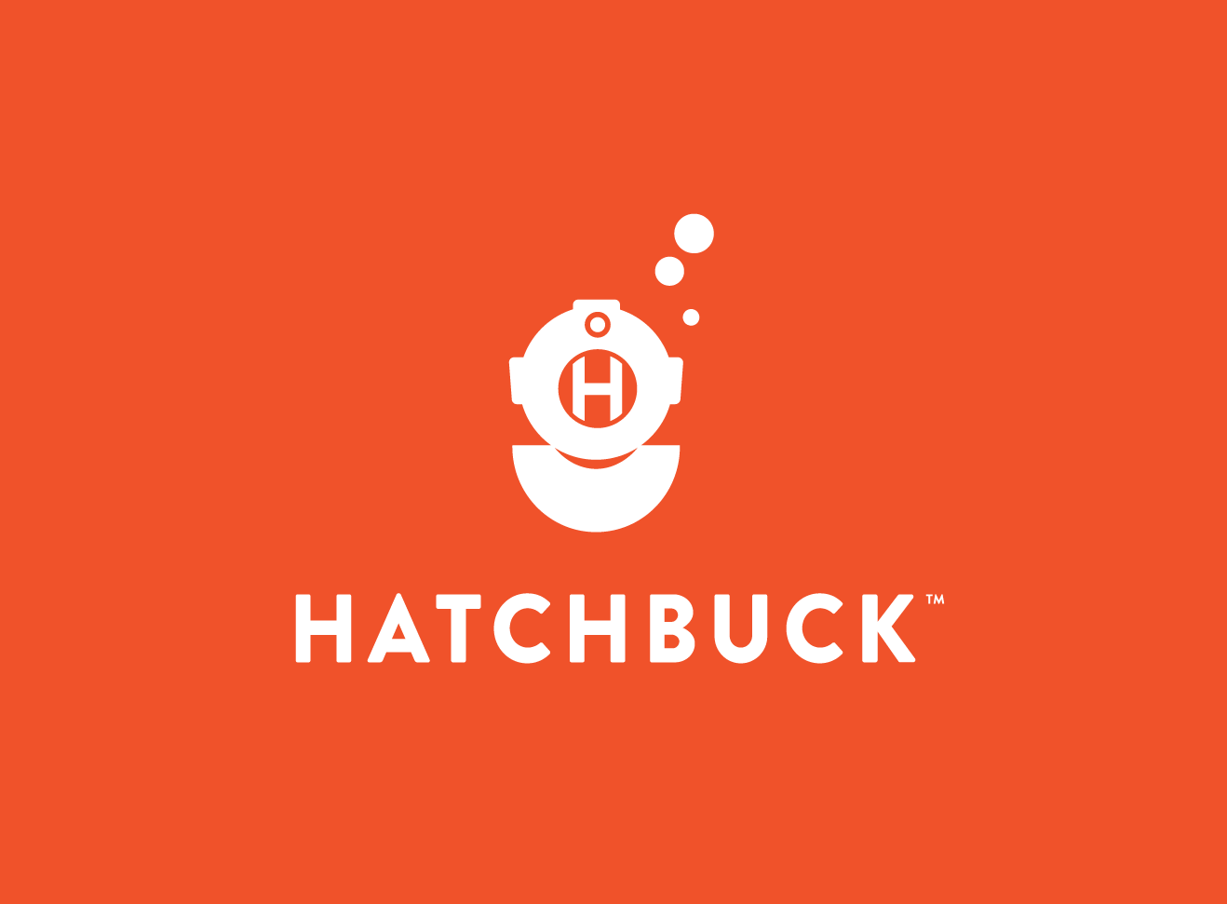

* Teddy Pobee
* Rabab Turabi
* Yusuf Ahmed

GROUP MEMBERS:

CRM SYSTEM

GROUP PROJECT

The CRM application for Vandeven Car Wash Business

After research, testing and demoing the CRM system that will be implemented for Vandeven Car Wash we decided to go with the Hatchbuck CRM Software. The reason we will go with this Hatchbuck CRM is because of its continual ease of installation and support on most operating systems; not excluding Windows, Linux, and Mac OS. In addition, Hatchbuck comes out of the box with some amazing and important features for all types of businesses. Below are detailed descriptions and breakdowns of the some of these features;  
  
Seamless Integration  
Hatchbuck is a CRM solution that comes with pre-built sales and marketing tools specifically geared towards small to midsize business. As this solution is designed purposely for small businesses, it fits into the category and setting of Vandeven Car Wash business model. This solution is also ideal since Vandeven car Wash currently has two locations and Hatchbuck has a package specifically for two accounts for a semi-annual cost of $99 per month. Hatchbuck has been designed to work on most operating system but mainly used and supported on Windows, Linux and Mac OS platforms respectively. With this in mind, Vandeven Car Wash will not have to change or have a technology overhaul to get Hatchbuck CRM system incorporated into their current system. Hence, making this CRM solution integrate seamlessly into Vandeven Car Wash.  
  
Product Functionality  
Technology has evolved over the years and this evolution comes with advancements in both the software and hardware sectors. There is software for anything you can possibly think of. With such an option at our disposal, it can lead to analysis paralysis. Thus, sometimes we are faced with too many options when it comes to choosing a solution to solve a specific problem. When it came down to choosing the CRM System for the Vandeven Car Wash business model, we were faced with a challenge. However, among all the CRM solutions out there, one thing that made Hatchbuck stand out was its qualities and functionality. As mentioned, the qualities of the Hatchbuck CRM meet the requirements of the Vandeven Car Wash business model. Some of these qualities that fit the business model are listed below.

Automation  
Automation can be described as the reduction of human intervention in any process needed to provide a product or service. As Vandeven Car Wash provides its services to its customer, it is deemed necessary to automate a lot of their tasks. The day to day tasks of the business already entails a lot of processes, such as cleaning cars, filling out customer information, creating accounts, and attending other special needs of the customers. Fortunately, the Hatchbuck CRM solution comes with a built-in system to help automate and take care of some of the workload needed for Vandeven Car Wash to provide the services required to satisfy its customers. Some of the built-in system and automation plug-in are sales automation, CRM automation, and Marketing Automation. For instance, the CRM automation system can help the managers on duty manage their day properly and worry less about creating or assigning tasks to the right associate and also monitoring those tasks. This is one of the strong automated features of the Hatchbuck CRM and is publicized and stated on the products’ website as "Automated task creation and notifications keep you on point all day. When you know what needs to be done, you have the freedom to prioritize where to spend your time." In addition to that, Hatchbuck CRM System comes with tools built and automated systems to help managers or the C level personnel track the company goals and deals. Thus, with this feature in place, individuals at a glance will be able to see how they are measuring up with their goals and also how the overall company is doing on their deals or special sales promotion.  This assists in providing insight into how the company is doing and increasing productivity. Due to how a lot of the processes in the CRM have been automated and tailored, it enables associate to access and add customer information into the system without having to go through a cumbersome process just to access, edit or provide service to a customer. In the long run, this helps cut down the time needed service a customer's account whether it be adding new customers or updating existing customers information.

Services and Integrations  
Even though there are a lot of solutions, software or applications for everything you can possibly imagine, a lot of these solutions do not integrate well with each other. For that reason, a lot of companies end up purchasing a lot of applications just to solve every individual problem or handle some form of work in their company. However, Hatchbuck, on the other hand, was built different. This is in a way to help users integrate other solutions in their system. This makes the tool a one-stop center for everything a business owner or user that need a good CRM system. Taking advantage of this integration helps increase and boost productivity since users do not have to open a ton of applications to accomplish their day-to-day tasks. And with this in mind, it will minimize the heavy use of resources on the end user’s system since there will be a few applications running. A few of the well-integrated system that Hatchbuck supports and incorporates into their system are Email Marketing, API integrations, In-App services amongst others. For instance, with Hatchbuck Email integration system, users have to leave the application to compose or build the right email template with the correct properties such as the headers and message. All these features are integrated into the solution. This feature alone will help an associate stay on track without getting buried in a ton of applications which could potentially make them deviated from the task at hand.  And most importantly since a lot of things are going mobile, all these templates are created to be both desktop and mobile friendly. With the CRM encompassing all these features, it provides a lot of advantages to the end user and the business as a whole. For instance, the email integration takes away the technical duties out of the job for the end users. Moreover, this email integration comes with other features such as autoresponders. With such a feature implemented, it helps the associate to focus more on providing good services to the customers rather than focusing on responding to emails. In addition to all the services and integration that Hatchbuck supports, one important service that is vital to every business or user is the support for API: API integration. As the customer base of a business grows, so does its solutions, architecture, software and everything needed to run the business. With this growth bound to happen in every business, there will be the need to implement new solutions to solve various issues as the business grows. For this reason, choosing a CRM system that is able to integrate with other applications is very critical. If the CRM does not integrate well, the business has to make changes to institute a new system that integrates well with it ongoing solutions and software and also its growth which can be time-consuming and tiring. However, with Hatchbuck CRM solution, this will not be the case as it already comes with an open library of APIs. This could prove to be helpful if an application or a third party vendor needs to integrate the application into another system (new or an existing system). The Hatchbuck API features both get and post requests. With these features in place, there are endless opportunities for automating more of the jobs of the Van business model if there should be a need to do so. For instance, a thin client or a self-service system can make an API call to the system to prompt customer if there is a need to update their information. In addition, whenever a customer buys a “wash”, they can make an API calls to system for the customer’s account to verify if the customer is a platinum member or a regular member. Based on that, the customers can get serviced accordingly when it is time for the associate to wash their cars. Moreover, at the core of every CRM system is the ability to track customer information, transactions and provide service and information such as fees, dates of service and supplies used. Other than these basic functionalities, not all CRM systems or solutions are built to provide any form of services outside of their basic functionality. For a business to grow and have a similar culture throughout the company regardless of its locations, it is very important for the manager and associate alike to collaborate, train and educate themselves. This can only be achieved via collaborating and training the associate with the culture of the company. Unlike the regular CRM system, Hatchbuck incorporates Zapier into its system. With Zapier, it makes it easy for the business to integrate over a thousand apps into the CRM system for collaboration, and virtual training. With this addition, managers will be able to assign the right training to the associates and be able to track those training. This is important as it can help boost the company's profit or returns. This is because, based on an associate's score or sales score, a manager will be able to figure out where the associate needs improvement and hence assign the right training to the associate which in the long run will better the associate and boost personal goals set for them by the company.  
  
CRM System Pricing  
In a competitive market, one might expect a strong positive relationship between price and product quality. This is very true for most products and services in the market today. Even though the quality of service or product provided does not really correlate with the prices paid for these products or services. This same principle is predominantly true to the price-quality relation for a CRM system. Often times, when we are making any form of purchases, we often use a product's price to determine if the product is affordable and also if the product or service possesses the quality we are seeking for. However, this was not the case when we were choosing the CRM system for Vandeven Car Wash as Hatchbuck CRM is one of the cheapest paid CRM solution on the market with prices ranging from $29 for a single user(starters), $99 for two users (small business), $199 for five users (Team), and $299 for ten users(Professional). All these prices are based on semi-annual fee terms, meaning the business only have to pay for this service twice a year regardless of which package you choose. Since Vandeven Car Wash falls into the small business category, we decided to go with the small business package as the price is good and moderate. This fits Vandeven Car Wash current business model since the company currently has only two locations. Purchasing any other package would provide the business with resources they are not going to use in the current state.  
  
Help and Support  
Not all systems comes with dedicated support after you purchase the product or service. Sometimes the support of these products comes as an extra cost, as this is one of the many way vendors make money from their product or service.  However, the Hatchbuck CRM solution provided dedicated support for its users at low cost. This support includes regular patching and updates to the system. This is critical to the business, as these patches frequently address security vulnerabilities or troublesome bugs in the code. This is vital because running on a non-updated system or technology leaves your systems with unresolved issues that can lead to a lot of vulnerabilities such as cyber-attack and in some cases complete data loss (Which mostly comprises of customer information).   
In addition to the above in-app support, Hatchbuck also provides technical assistance of all forms and shapes. Thus, their team of experts does not provide assistance on their product alone but also assist businesses with the technicalities pertaining to marketing, Search Engine Optimization among many other things needed for a business to run smoothly. They provide these supports for a slight fee or can guide the user through a DIY approach via a free downloadable document from the website.  
  
Operating System and System Information  
The operating system is the most critical part of the computer system and architecture as it provides the functionality required to manage processes. It plays a vital role by running software and application, scheduling tasks and controlling the peripherals. Due to this, it is important to choose the correct operating system based off of the usage that will be required. Taking many factors in to consideration, especially the financial aspect being the biggest contributing factor to our decision making; it was wise to go with an operating system that is stable and also costs less to nothing to maintain. For this reason, we chose Linux. Within Linux, it’s important to understand the various flavors and distributions that are available to our disposal. We specifically chose the Ubuntu distro to run our system for Vandeven Car Wash. The main reason being the convenience and ease of access that is provided within this distribution. Ubuntu’s user interface is better known as Unity. It provides a simple GUI while being highly productive. Since we want to run a CRM application with set goals in mind, it is important to aim for a light weight yet viable option which will get the job done without complications. This is also to keep in mind that the business may require user training for the system and Ubuntu is also known to be one of the best distros for beginners or non-technical users.  
When it comes to servers, amongst the other operating systems in the market, Linux has proven to be one of the most utilized operating system. Since it is open source, it is less costly compared to the other options. Security is an important factor when it comes to businesses. Since this will be used to track customer information and transaction information; it is key to remember that this is highly sensitive data that can be misused if it’s not passing through a secure passage. With Linux, viruses and malwares are not an issue, which is why it would be viable to choose this OS over others.  
Moreover, when it comes down to installing or implementing an operating system, requirements play a vital role as to what the operation system’s main functions will consist of. We chose Linux and Ubuntu distro because of the minimal requirements it needs to run. Not only that, but Linux is known to be compatible with older and newer hardware alike. Since it is able to thrive on older systems, there will be no need to replace the hardware in order to support the recent version or update of the operating system. Unlike Linux, other vendors such as Windows need high hardware requirements in order for their operating system to run.

Merits of the Ubuntu Server System  
The Ubuntu server operating system is one of the most used servers operating systems in the world. The reason for its popularity in the server operating system space is due to its open-source technology. Because it is open-source, it opened doors for developers all over the world to contribute to it. As a result of the contribution from developers all over the world, it gives Linux a security advantage over some of the well-known operating systems. This is because a lot of these contributors are mostly hackers and developers. They have contributed to making Linux's security system much better. As money is a limited resource for the Vandeven Car Wash, they there will not be a need to spend hundreds of dollars to purchase an external advance anti-virus system. In addition to the above, since the source code of the operating system is available to everyone, some experts and veterans help with identifying the security flaws or issues and work to resolve those issues. For these reasons, Linux stands out among the operating system due to a wide range of support and contributors.   
In addition to the above benefits, Linux and the Ubuntu distro comes with one of the best support systems one can ever get compared to other operating systems on the market. Thus, unlike other operating systems that require you to hire an expert to solve a problem whenever one arrives, the Ubuntu operating system has a huge and widespread community filled with developers, systems administrators, and good hackers that offers both advice and assistance at no cost. Most of the problems that an administrator will experience, have either been answered on a thread in the community or will get assistance within the shortest period after creating a thread for the issue. With this in mind, it enables Vandeven Car Wash to spend time on other issues without sacrificing anything. This also cuts any associated costs with needing external support with any sort of payment.  
Lastly, another important reason why we chose the Ubuntu server operating system for Vandeven Car Wash is due to is reliability over the past years. Ubuntu is said to be reliable than the other server operating system for a number of reasons. The reasons include, for instance, with the Windows operating system, every major change update requires a system reboot which causes the system to be offline for a certain period of time. These updates or changes can include simple software installs and updates. On a Linux system, this is not the case, which means it would interrupt or impede on the business activities, hence increasing productivity.  
  
Hardware to Host the Operating System and CRM system  
According to information on the Ubuntu Help web page, for the operating system to run, it needs to be installed on hardware that is at least 300 MHz x 86 processors, 256 MB of system memory, 1.5 GB of disk space, graphics card and monitor capable of 640x480 and a CD drive. When we compared these requirements of the specifications to the hardware Vandeven Car Wash currently has in place, we came to the conclusion that the operating system will be a suitable match in this environment.  
The hardware that is currently in place is the HP ProLiant ML330 G6 – Xeon E5507 with a clock speed of 2.26 GHz. For starters, this piece of hardware is specifically recommended for small, corporate business. This has a quad core processor which means 4 independent units will be running various tasks and processes. This also means, the performance will be more efficient and will allow for the running of simultaneous tasks. Another requirement to run the operating system was a minimum architecture of x86. The current hardware is x64 which means the hardware in place is in the category of the newer systems. Moreover, 64-bit computers have some greater advantages. One of them being, they are compatible with 32-bit programs as well. On the other hand, 32-bit computers are unable to run 64-bit programs because the bit sizes are fundamentally different. In addition to this, the minimum RAM required by Ubuntu is 256 MB. Fortunately, the system comes with 2GB of installed RAM which is upgradable to 144 GB which is more than enough. The more memory that is available for use; the CPU will directly access it and swap data from the RAM which would mean a greater and visible increase in speed when running applications. The Ubuntu server operating systems also requires a minimum of 1.5 GB of disk space. The hardware in place has a capacity of 146 GB which covers that requirement too. With a good system, redundancy and backup is vital for ensuring protecting against data loss. Since the business works with information like inventory data and customer tracking, loss of this information can result in an apparent loss within the organization itself. The organization is more prone to losing its credibility. The hardware allows for the implementation of RAID 0, 1 and 10. These are proficient backup options for the system in its entirety. The critical aspect of this feature would be memory mirroring and redundancy amongst all the stored information. In the case of information loss, since the blocks are either mirrored, striped or both; data can be retrievable.

All in all, the business will not have to spend on buying extra hardware since the current one is compatible with the OS and the applications that will be in use. This CRM proposal will prove to be viable and efficient not only from the hardware aspect but will also provide for a fluid-like and manageable performance of the software as well. We believe that this solution will be user-friendly, cost effective and ensure great success for Vandeven Car Wash.

*CRM Solution: Teddy*

*Hardware and Operating System: Rabab*

*Operating System: Yusuf*

*Final Editing / Revision / Summary of Entire document: Rabab and Teddy*

Works Cited

Evangelho, Jason. “5 Reasons You Should Switch From Windows To Linux Right Now.” Forbes, Forbes Magazine, 30 July 2018, www.forbes.com/sites/jasonevangelho/2018/07/23/5-reasons-you-should-switch-from-windows-to-linux-right-now/#251dd734777b.

“HP ProLiant ML330 G6 - Xeon E5507 2.26 GHz - Monitor : None. Series Specs.” CNET, CNET, www.cnet.com/products/hp-proliant-ml330-g6-xeon-e5507-2-26-ghz-monitor-none-series/.

“Marketing Software, CRM and Marketing Automation Built for You.” Hatchbuck, www.hatchbuck.com/.

Quirk, Kev. “6 Things That Ubuntu Does Better Than Windows.” MakeUseOf, 15 Sept. 2016, www.makeuseof.com/tag/6-things-ubuntu-better-windows/.

“Ubuntu Documentation.” Installation/SystemRequirements - Community Help Wiki, Ubuntu, help.ubuntu.com/community/Installation/SystemRequirements.